Scoping the functionality of a DSS for water quality improvement in the Great Lakes region of NSW
W.S. Merritt ª, N. Herron ª and R.A. Letcher ª

ª Integrated Catchment Assessment and Management (iCAM) Centre, The Fenner School of Environment and Society, The Australian National University, Australian Capital Territory

Email: wendy.merritt@anu.edu.au
The Great Lakes Coastal Catchments Initiative (CCI) will develop Water Quality Improvement Plans (WQIP) for Myall Lakes, Smiths Lake and Wallis Lake. Catchment water quality and estuarine models have been developed by the NSW Department of Environment and Climate Change (DECC) and project partners will identify interventions to prevent and reduce suspended sediment and nutrient loads to the lakes. Knowledge from these project components will be integrated into a decision support system (DSS) for water quality improvement.
The Great Lakes CCI project is part of a federally funded program and considerable resources are being put into the development of the WQIP. Central to the project is the engagement of all parties who have an interest in maintaining and improving water quality in the Great Lakes. The Great Lakes Council (GLC) is managing the project and have set in place an Engagement Strategy that focuses on (Tucker, 2006)
- raising awareness of the project within the local community so as to establish how people would like to be involved in the project; and
- capacity building and joint learning with key sectors of the community and key individuals in organisations involved in the management of the lakes and their catchment.
The latter, in particular, is intended to support and drive change that will lead to sustainable management of the regions land and water resources.
The CCI Advisory Committee – comprising individuals involved in natural resource management as well as industry and community groups – plays an important role in capacity building for the project. Researchers are working closely with the committee to build capacity. Facilitated workshops have been run to scope the role of component projects and identify key values and issues in the three systems.
The Great Lakes DSS is intended for use by non-technical users to readily set up scenarios in the DSS and analyse their impacts on estuary values. It is anticipated that it will play a critical role in upcoming meetings to negotiate the WQIP and further enhance group understanding of the potential impacts of catchment land use change and management on the estuary.
The committee has played a vital role in guiding the focus and development of the component projects. It has contributed to the initial conceptualisation and subsequent refinement of the DSS model framework, particularly the identification of scenarios and key impacts. Another role has been information supply, identifying existing data and knowledge that will inform the DSS as well as potential contacts for consultation. As the DSS is progressed, the committee will also have a role in reviewing it in terms of its content, behavior and plausibility.
The development of the Great Lakes DSS is greatly benefited by being part of the well supported CCI project, which features
- a project co-ordinator dedicated wholly to management of the project,
- existing strategies and processes for community engagement,
- modelling and field research components that will inform the DSS, and
- significant contributions from the CCI Advisory Committee and agencies involved in the management of the lakes.
This support is guiding the DSS development and should enhance adoption and use of the final tool.
Decision Support System (DSS), Coastal Catchment Initiative (CCI), water quality

INTRODUCTION
Coastal and estuarine environments in New South Wales (NSW) are recognised as having high economic, environmental, cultural and social values. They support a rich diversity of habitats, which sustain regional economies through fisheries, tourism and other industries. If strategies are not put into place to minimise potential deleterious impacts, increased population pressure along the central and north coast of NSW may have repercussions for the health of estuarine ecosystems in the region and the economies and communities that they support. Increasing pressures have already led to a decline in the ecosystem health of some estuaries, as measured by eutrophication caused by elevated nutrient inputs (e.g. Webster and Harris, 2004), alterations in hydrologic, hydrodynamic and/or geomorphic regimes (e.g. Lee et al., 2006) and changes in the biodiversity and distribution of aquatic communities (e.g. Harty, 2004). Declining water quality may also lead to loss of recreation value and have negative impacts on aquaculture and commercial fisheries. A key question is how do we take account of all these different values when developing management plans or policies guiding the use of land and water resources?
Balancing human activities with ecosystem health requires managers of coastal systems to possess in-depth understanding of processes operating in waterways and their catchments. Models and Decision Support Systems (DSS), when well-constructed, offer a way to achieve more informed decision-making through the integration of environmental, economic, social, and political impacts of management decisions.
An ideal DSS should support and enhance managerial judgment and be aimed at improving the effectiveness, rather than the efficiency, of decision making (Rizzoli and Young, 1997). When developing a DSS, iCAM concentrates on constructing tools that are
- relatively simple to allow for extension to ‘non-technical’ people,
- complex enough to be rigorous and defensible in terms of economic and social impact analysis as well as scientific foundation,
- sufficiently flexible to adapt to new situations, and
- developed in close consultation with decision makers
The tools should also have the capacity to integrate knowledge from a range of disciplines, sources and scales and explicitly account for imperfect knowledge and uncertainty.
This paper describes scoping activities for a Decision Support System (DSS) for the Great Lakes Coastal Catchments Initiative (CCI) – a federally funded project for water quality improvement in the Myall, Smiths, and Wallis Lakes. Critical to the success and adoption of the DSS is the sense of ownership that the key agencies involved in the management of water quality in the three lakes will have of the DSS and its contents. Here we describe the main elements of the DSS and give details of how key stakeholders have been involved in the DSS design process.
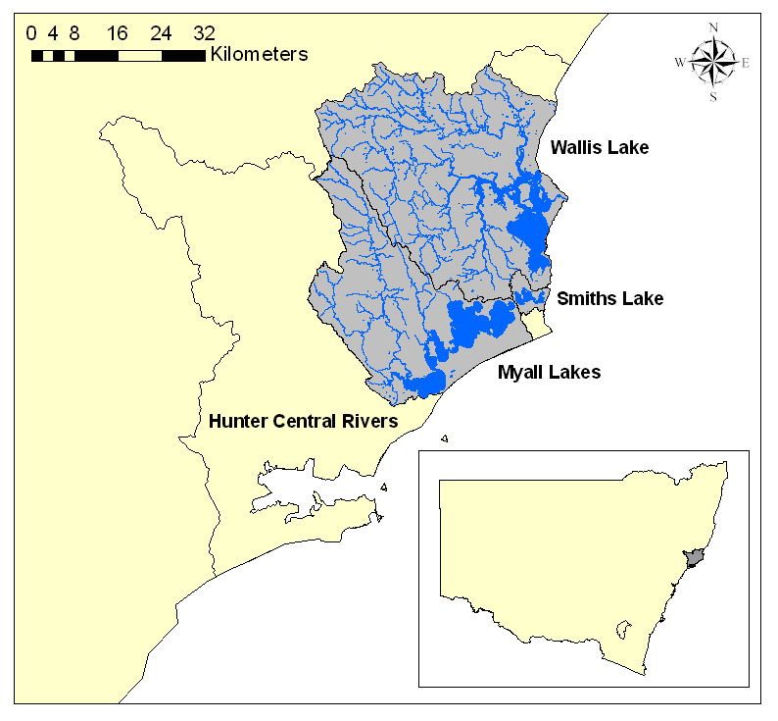
Figure 1. Great Lakes CCI project: Myall, Smiths and Wallis Lake.

THE GREAT LAKES REGION
The Great Lakes (Figure 1) comprise the Myall, Smiths and Wallis Lakes. They are significant environmentally for the habitat they provide to a large number of native flora and fauna species, including a number of endangered and vulnerable species. In addition, the lakes represent a significant resource to the local communities through income generated from prawning, oyster farming, fishing and recreational activities.

THE GREAT LAKES CCI PROJECT

Overview
The CCI, a National Water Quality Improvement Program, is being implemented in partnership with Australian States for one or more coastal water quality 'hotspots' in each jurisdiction.
The Great Lakes CCI project (here-on-in referred to as the CCI project) is managed by the Great Lakes Council (GLC) and will develop Water Quality Improvement Plans (WQIPs) to guide future management of the lake resources. These plans will
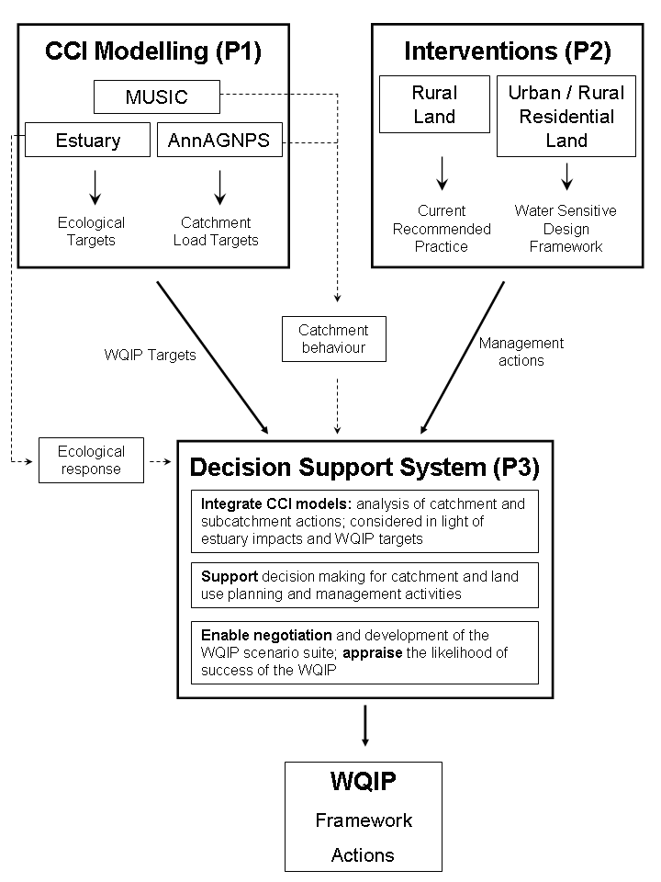
Figure 2. The CCI modelling and interventions component projects will inform the Great Lakes CCI DSS. The DSS can be used to negotiate and develop the WQIP framework and actions.
- establish a framework for the implementation of water quality improvement actions by establishing a transparent process for decision making that is linked to statutory planning and other decision-making processes;
- allow councils and government agencies to carefully consider water quality issues brought about by development pressures within the catchments; and
- guide investment by all parties (Federal, State and Local Governments, community and environment groups).
(http://www.environment.gov.au/water/publications/action/case-studies/nwqms-cci.html, Accessed 17 July 2007).
Three component projects have been established, which will underpin the development and implementation of the WQIPs. They are:
- Catchment and estuarine modelling of sediment and nutrient loads to Myall, Smiths and Wallis Lakes (P1);
- Intervention strategies to prevent and reduce suspended sediment and nutrient loads to Myall, Smiths and Wallis Lakes; and (P2); and
- A decision support system (DSS) for water quality improvement in Myall, Smiths and Wallis Lakes (P3).
An overview of the CCI project components and how information feeds into the DSS is given in Figure 2.

Engagement Strategy
Key principals of the CCI project are power sharing between all levels of government and the local community, and the recognition of a “need to move into collaborative space and establish a level of trust and transparency in the development of water quality improvement plans” (Tucker, 2006). The engagement strategy for the CCI project has been developed to promote sustainable management of the Myall, Smiths and Wallis Lakes.

The CCI Advisory Committee
An Advisory Committee was formed early on, comprising representatives of key organisations and groups with an interest in the management of the lakes and their catchments (Tucker, 2006). The committee includes representation from the Hunter-Central Rivers Catchment Management Authority (HCR-CMA), industry groups (e.g. Wallis Lake Fishermans Co-op, oyster growers), the Hunter Councils, the Department of Environment and Climate Change (DECC), and local community members. Much of the committee’s contribution to the project has been through regular meetings involving
- the presentation of methods and results by component project researchers, and
- facilitated workshops to scope the role of component projects or identify/review values and issues in the three study systems.
The Advisory Committee’s contribution to the development of the DSS is via
- Conceptualisation and refinement of the model framework, particularly the identification of scenarios and key impacts;
- Information supply – identification or provision of existing data/knowledge, as well as potential contacts for further consultation;
- Model review – the prototype DSS will be made available to the committee for reviewing content, system behavior and plausibility.
Once developed, the DSS will be an invaluable tool for planning and negotiating the WQIP in a workshop setting. Scenarios can be defined and run quickly, thus enabling the Advisory Committee to explore and compare a large range of WQIP options.

The Technical Committees
For each project component, a Technical Committee has been established to guide the advancement of the component project, and where relevant, contribute to the identification of options for the management of rural and urban areas. These groups comprise representatives from the GLC, the Department of Environment and Water Resources (formerly the Department of Environment and Heritage) and key agencies. For example, the rural management practice Technical Committee includes staff from the HCR-CMA and DECC as well as the Landcare Sustainable Grazing Officer.

Engagement of the local community
The CCI project has a broad scope and involves collaborations between researchers and staff from many organisations. The GLC has employed a CCI co-ordinator to manage the project and to promote and raise awareness of the project, develop partnerships and undertake community consultation and education activities.
A key role of the Engagement Strategy was to involve the local community in the development of the WQIPs. A comprehensive list of stakeholders was identified by council and the advisory committee. These groups and key individuals were approached and invited to find out more about the project and be involved in the initial stage of the development of the WQIPs (Tucker, 2006). This stage involved the identification of the uses and values of the waterways by the community. This information informed the DSS scoping activities (Section 4.1) and will define the water quality objectives set out in the plan.
Community workshops conducted by the GLC in 2006 and 2007 identified many values associated with the Great Lakes waterways. Several issues were focused on:
- Past and current uses of the region’s waterways;
- Concerns about losing specific or favoured attributes from the region’s waterways;
- What participants cherish or appreciate about the region’s waterways;
- Concerns or pressures affecting water quality;
- Future use of the region’s waterways;
- Better management practices.
Key uses of all the waterways and their surrounds are: wildlife watching, boating, land-based recreational activities on foreshore areas, use of water for agricultural activities and human consumption; swimming and fishing. The general attributes of the waterways that are valued include:
- Visual amenity – beauty and clarity of the water, babbling brooks, colour and clarity of marine life; peace and quiet;
- Easy access – free to use, recreation access, agricultural access; living near and being able to easily access waterways;
- A haven for endangered species, flora and fauna;
- Lack of overdevelopment.
Community members also discussed threats to the activities and values they hold for the waterways and their surrounds.

COMMUNITY ENGAGEMENT AND THE DSS

Scoping the DSS
Initial scoping activities for the DSS involved
- Identification of system drivers, processes and impacts to consider in the DSS;
- Identification of potential uses and users of a water quality DSS; and
- Development of a conceptual framework for each of the Myall, Smiths and Wallis Lake systems
At an Advisory Committee meeting in August 2006, iCAM facilitated a workshop to identify the potential end-users and roles of the DSS. The purpose of the workshop was to identify
- Who are the intended end-users?
- What do they want to know? Why? How and for what purpose would they like to use this knowledge?
- When do they want to know this information or what are the triggers for them using the DSS (i.e. on a regular basis after completion of the CCI project or only to develop the WQIPs)?
A scoping report was circulated to the advisory committee in November 2006, which outlined potential management actions and key values for each system using outcomes from the workshop and from the community workshops outlined in Section 3.5. Feedback was sought on the actions, values and conceptual frameworks identified in the report. This feedback was used to refine the conceptual framework of each system.
Table 1. Potential uses and users of a water quality focused DSS
Purpose | Groups
Assessing impacts of projects or proposals | GLC, Road Traffic Authority, Department of Planning, HCR-CMA, DECC, Landcare, Rural Fire Service
Educational tool / Understanding lake systems | DECC (including the former Marine Park Authority)
Information and/or  lobbying purposes | Estuary Management Committees (EMC), and industry, environmental groups, aboriginal groups
Support (or prioritise) funding applications | Catchment management groups, Landcare
Planning and management | GLC, DECC, MidCoast Water
Identification of current and future threats | NSW Food Authority, DPI (Fisheries)

The many stakeholders in the three catchments have varying uses for a DSS that addresses water quality management (Table 1). Within each organisation, there can be a wide range of scales and actions that users are interested in. For the GLC, local planners might be interested in assessing actions at a subcatchment scale (e.g. re-zoning for development), while staff working in natural systems might require tools to assist decision-making at the property scale or the scale of urban developments.
The following needs were identified for the Great Lakes CCI DSS. It should
- provide a summary of reports and what is known about values and impacts,
- allow detailed design of water quality scenarios,
- allow detailed analysis of water quality impacts,
- incorporate some detail of urban development impacts, and
- provide easily understood summaries of impacts on key values of the lakes and catchments.
Outcomes from the scoping activities have been used to develop specifications for the content and functionality of the DSS and its capacity in facilitating management of the lakes.

THE GREAT LAKES CCI DSS

Capacity of the DSS
The DSS will be underpinned by catchment water quality and estuary modelling results as well as results from modelling of urban water quality scenarios. The DSS will:
- integrate results from these different models and allows their results to be analysed at catchment and subcatchment scales and considered in light of estuary impacts,
- integrate information from hundreds of runs,
- allow non-technical users to readily create a scenario and analyse its impacts,
- be run during Advisory Committee meetings to enable negotiation of the WQIP scenarios and group understanding of potential impacts, and
- provide a centralised repository of modelling and documentation on results of the project which can act as a memory of project methods, results and outcomes.
The tool is being designed such that it can be readily updated with new information in the future, thus allowing (a) the WQIP to be updated and reviewed as necessary and (b) the tool to be used for other catchment and land use planning and management activities.

Model Structure
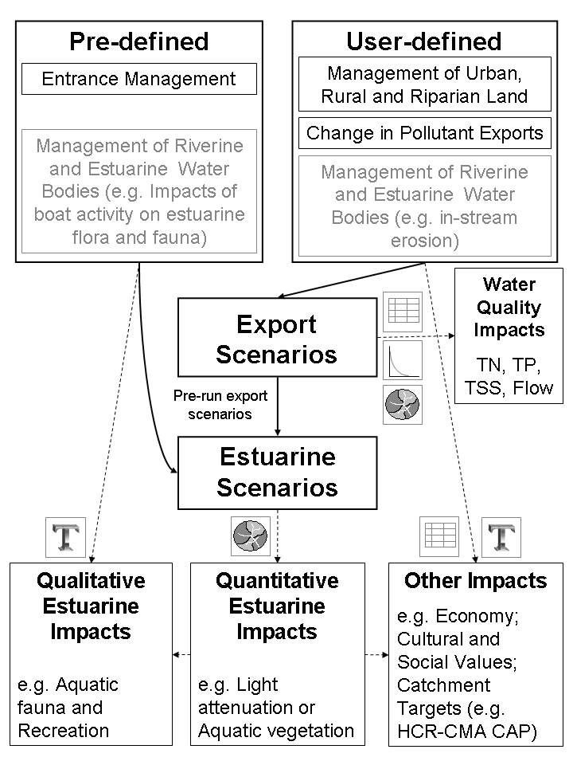
Figure 4. Examining catchment water quality scenarios and their impacts on values in the Great Lakes. Impacts may be represented using graphs (), maps (), tables () or text ( ).
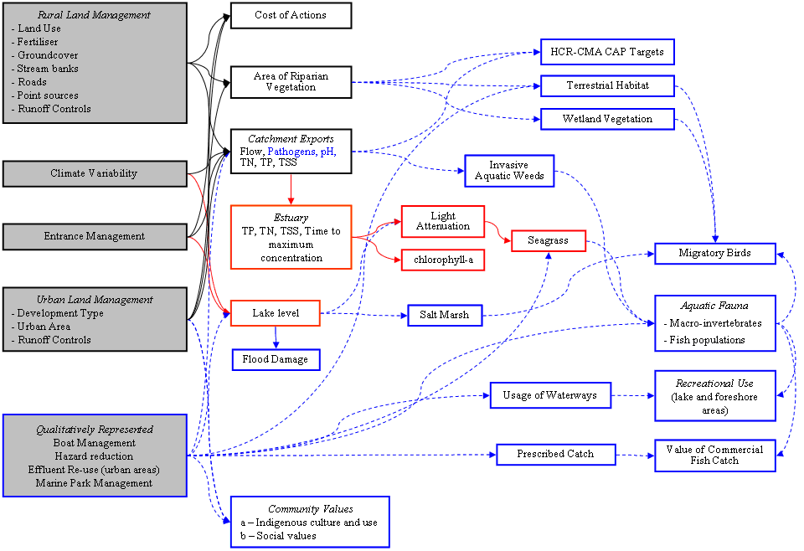
Figure 3. Conceptual framework used the Smiths Lake CCI DSS. Black boxes represent impacts that will be determined from scenarios that drive the catchment water quality models. Red boxes indicate estuarine impacts that modelled numerically and blue boxes are impacts that will be described with textual information.
The conceptual framework for Smiths Lake (Figure 3) shows the components of the system, represented as nodes, which were identified as necessary for inclusion in the Smiths Lake DSS. These values were identified from scoping activities (Section 4.1) as well the outcomes from engagement activities with the local community (Section 4.2).
A simplified diagram of how the DSS will operate is shown in Figure 4. Users will be able to define spatially explicit scenarios (i.e. specific to subcatchments) that relate to the management of riparian, rural, and urban land (‘Management’ scenarios) or as changes to subcatchment pollutant loads (‘Target’ scenarios).
Scenarios will be run for one or more individual subcatchments within each system or for all subcatchments. The water quality and quantity impacts being considered are total nitrogen (TN), phosphorus (TP) and suspended sediments (TSS) and flow. Results will be reported for individual subcatchments and/or the whole-of-catchment, and impacts will be able to be viewed as maps, column charts, and/or tables of data. These results will provide users with a quantitative assessment of the spatial distribution and temporal range in catchment flow and pollutant exports and will feed into the estuary component of the DSS.
Once users have designed and run water quality scenarios, they can examine impacts of a pre-run water quality scenario on estuarine nodes (e.g. light attenuation or chlorophyll-a), either individually or in combination with pre-determined estuary scenarios (e.g. entrance management).
Impacts on nodes such as aquatic fauna cannot be quantified using the models developed in the CCI project components. In the Great Lakes CCI DSS, existing literature and local information will be summarised to highlight likely relationships between these values and catchment or estuary condition.

DISCUSSION AND CONCLUSIONS
The Great Lakes DSS is being constructed to support the development of the Myall, Smiths and Wallis WQIP and will have a broader role in facilitating improved catchment planning.
Despite their potential, many DSS have not been widely adopted and used in real planning processes, or have not been overly successful in informing and supporting decision-making. We aim to minimise this risk by ensuring that the GLC and other stakeholders have ownership of the DSS and have contributed substantially to its design and contents. This process will provide them ownership of the DSS and the development process, and is crucial to ensure a tool that adds value to planning processes in the Great Lakes region.
The appointment of a project co-ordinator who is dedicated wholly to management of the CCI project, together with the existing strategies and processes for community engagement, provides an environment that encourages input to the DSS construction. Once developed, the DSS can feed back into the engagement process with the local community.

ACKNOWLEDGMENTS
The Great Lakes Coastal Catchments Initiative is majority funded by the Australian Government's Natural Heritage Trust. The authors acknowledge the efforts of Prue Tucker of the Great Lakes Council who has managed the project and provided considerable time to this work.

REFERENCES
Harty, C. (2004). Planning strategies for mangrove and saltmarsh changes in southeast Australia. Coastal Management, 32, 405–415.
Lee, S.Y., Dunn, R.J.K., and Young, R.A. (2006). Impact of urbanization on coastal wetland structure and function. Austral Ecology, 31, 149–163.
Rizzoli, A.E., and Young, W.J. (1997). Delivering environmental decision support systems - software tools and techniques. Environmental Modelling and Software, 12, 237-250.
Ticehurst, J.L., Newham, L.T.H., Rissik, D., Letcher, R.A. and Jakeman, A.J. (2007). A Bayesian network approach for assessing the sustainability of coastal lakes in New South Wales, Australia. Environmental Modelling and Software, 27(8), 1129-1139.
Tucker, P. (2006). Building a foundation for water quality improvement by engaging people in planning – the Great Lakes Coastal Catchments Initiative. 15th NSW Coastal Conference, Coffs Harbour, NSW, 7 – 9 November 2006, Conference CD.
Webster, I.T. and Harris, G.P. (2004). Anthropogenic impacts on the ecosystems of coastal lagoons: modelling fundamental biogeochemical processes and their implications. Marine and Freshwater Research, 55: 67-78.

